

|  |
| --- |
| Financial Overview  2021 |
|  |
| December 2021  Kraton Corporation  Authored by: Rohra Yogesh |

[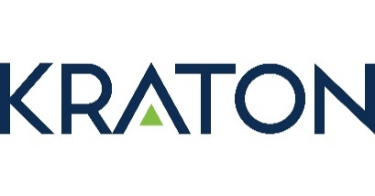](https://kraton.com/)

# A picture containing building, outdoor, sky, city Description automatically generatedContents

|  |  |
| --- | --- |
| 1. Company Profile | 3-4 |
| 1. Stock performance (last quarter) | 5 |
| 1. Financial Analysis |  |
| 1. Revenue Performance | 6 |
| 1. Asset Performance | 7 |
| 1. Liabilities and Equities outstanding | 8 |
| 1. Cash flow | 9 |
| 1. Trends | 10 |
| 1. Enterprise Valuation Analysis | 11 |
| 1. Projections (5 years) | 12-13 |
| 1. Technical Analysis (Beta calculations) | 14 |
| 1. Valuation Analysis Appendix | 15-16 |
| 1. Technical Analysis Appendix | 18-19 |

# 1. Company Profile

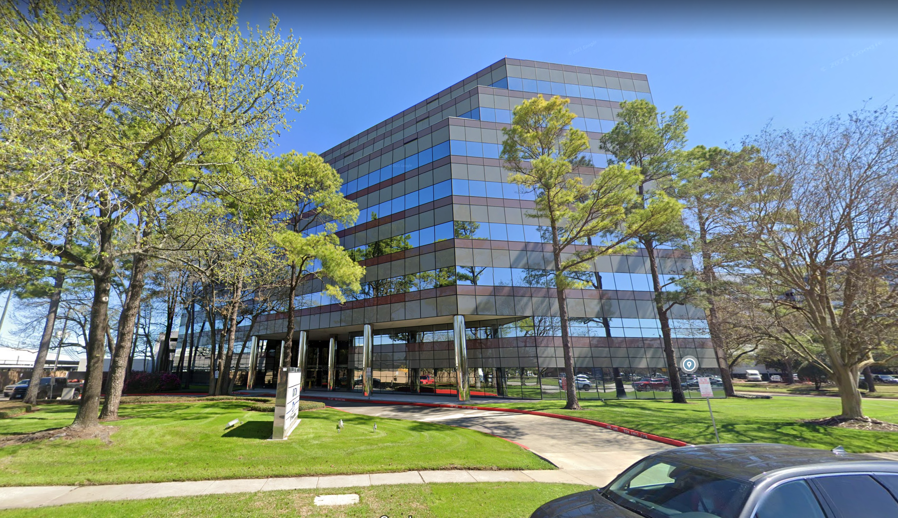

* Kraton Corporation manufactures and sells styrenic block copolymers, specialty polymers, and other products in the Americas, Europe, the Middle East, Africa, and the Asia Pacific.
  + It operates in two segments, Polymer and Chemical.

Headquarters: 15710 John F. Kennedy Boulevard  
 Suite 300  
 Houston, TX 77032  
 United States

Contact: [281 504 4700](tel:2815044700)

Webpage: <https://kraton.com/>

* It sells its products through various channels, including direct sales force, marketing representatives, and distributors under the Kraton brand. The company was formerly known as Kraton Performance Polymers, Inc. and changed its name to Kraton Corporation in September 2016. Kraton Corporation was incorporated in 2009 and is based in Houston, Texas.

|  |  |
| --- | --- |
| * The Polymer segment offers performance products, including styrene-butadiene-styrene for paving and roofing application; styrene-isoprene-styrene for personal care application; ethylene-vinyl acetate, polyolefins, and metallocene polyolefins for adhesives application; and specialty polymers, such as hydrogenated styrenic block copolymer, isoprene rubber, and isoprene rubber latex for use in medical and personal care products, adhesives, tackifiers, paints, and coatings. |  |

|  |  |
| --- | --- |
| * The Chemical segment provides pine-based specialty products that include rosin-based tackifiers for packaging and pressure-sensitive adhesive applications; terpene-based tackifiers for bookbinding, hygiene, and pressure-sensitive adhesive applications; alpha-methyl-styrene (AMS) resins for bookbinding and pressure-sensitive adhesive applications; and hot melt polyamides for flexible packaging, industrial, and road making applications. |  |

# 2. Last quarter stock performance against S&P

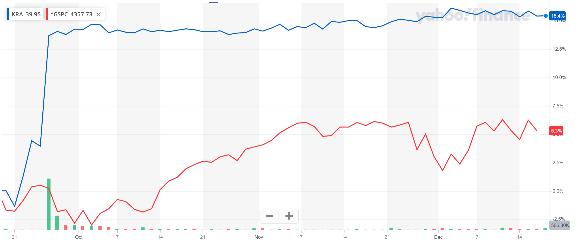

* KRA observed a quarterly average price of $46.03
* KRA observed a quarterly average increase in price by 0.34%
* S&P observed a quarterly average price of $458.64
* S&P observed a quarterly average increase in price by 0.05%

# Last quarter stock performance against Competitors (Celanese Corporation & Steel Dynamics, Inc.)

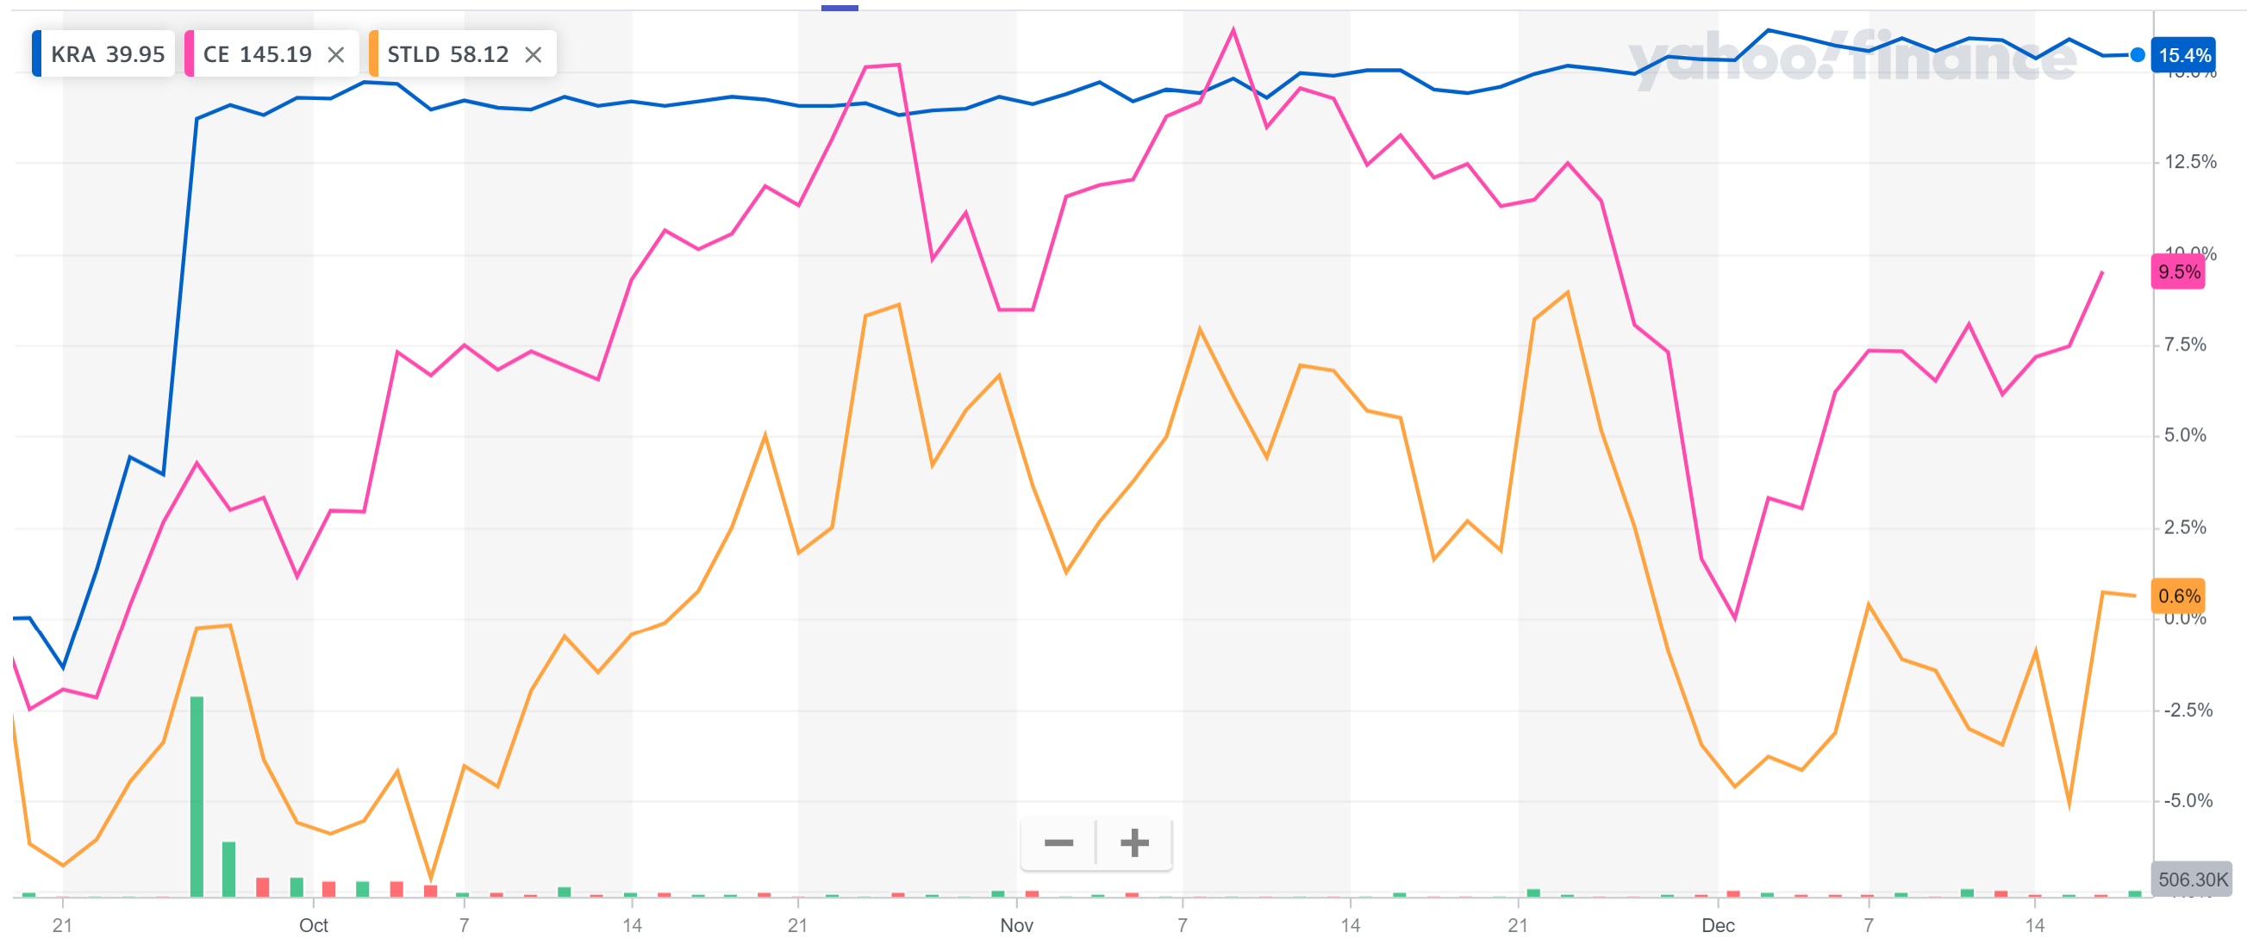

* CE observed a quarterly average price of $156.17
* CE observed a quarterly average increase in price by -1.09%
* STLD observed a quarterly average price of $61.13
* STLD observed a quarterly average increase in price by -3.44%

# 3. Financial Analysis

a. Revenue Performance

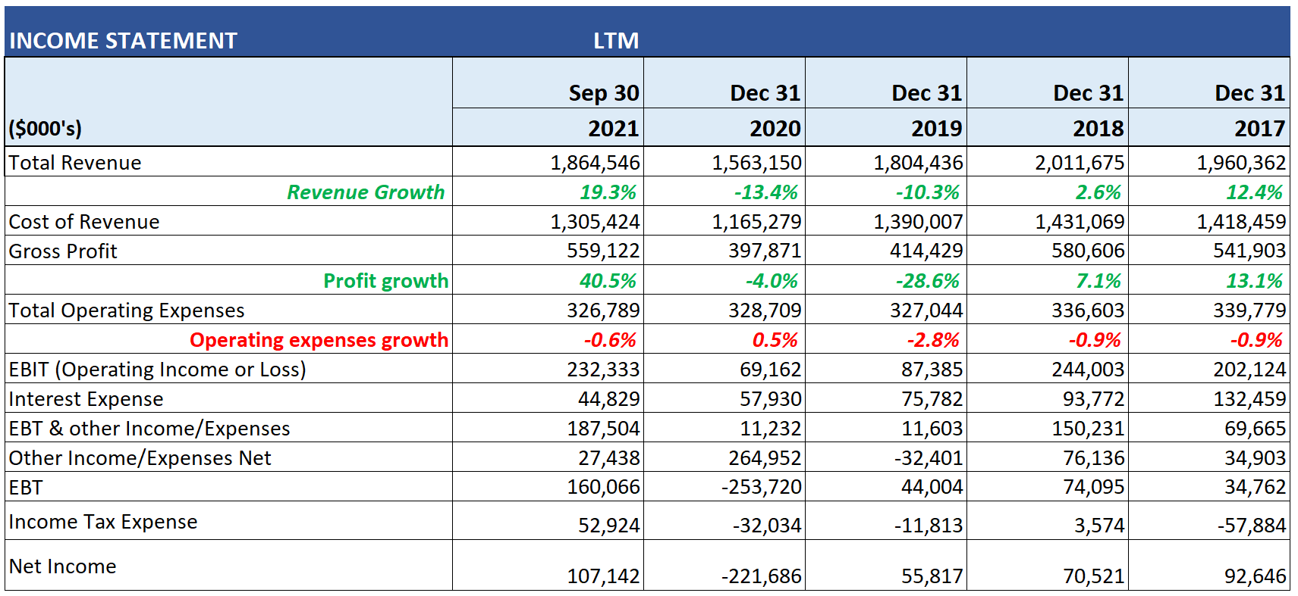

* A significant revenue loss was observed from 2018 to 2020. Kraton was already facing a continuous drop in revenue pre-covid. Post-covid Kraton saw almost a 20% revenue growth.
* An average revenue growth of 2.1% was observed for last 5 years.
* A significant profit loss was observed from 2018 to 2020. Kraton was already facing a continuous drop in profit pre-covid. Post-covid saw Kraton almost a 40% profit growth.
* An average profit growth of 5.6% was observed for last 5 years.
* A significant loss in operating expenses was observed from 2017 to 2019. Kraton was already facing a continuous drop in operating expenses pre-covid. During covid Kraton saw 0.5% growth in operating expenses. Following with a drop of 0.6% post-covid.
* An average operating expenses loss of almost 1% was observed for last 5 years.

# 3. Financial Analysis

b. Asset Performance



* A significant growth in Cash was observed during covid for year 2020. Possibly Kraton was required to manufacture raw chemicals for sanitizer manufacturing and medical equipment for pandemic. Kraton saw almost a 150% cash growth for 2020.
* Post-covid a 5% cash growth was observed for 2021. An average cash growth of 12.12% was observed for last 5 years.
* A significant growth in Current assets was observed post-covid for year 2021. Possibly Kraton build a huge inventory to last for the pandemic. Kraton saw almost a 30% total current assets growth for 2020.
* Pre-covid a 15% asset loss was observed for 2021. An average asset growth of 3.14% was observed for last 5 years.
* An average Net PPE growth of 2.53% was observed for last 5 years.
* An average loss of almost 2% was observed in total assets for last 5 years.

# 3. Financial Analysis

c. Liabilities and Equities outstanding



* Similar growth of current liabilities has been observed for 2020 and 2021 of 18%. An average growth of current liabilities of 9% was observed for last 5 years.
* However, total liabilities for 2021 grew only by 1%. An average loss of total liabilities for 5 years observed was 5.3%.
* An average growth for stockholders’ equity over 5 years is 13%.

# 3. Financial Analysis

d. Cash flows



* 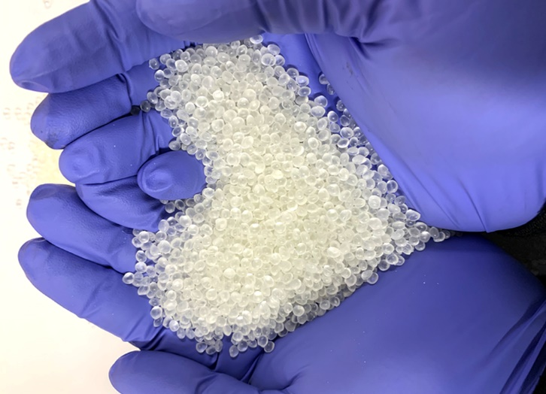An average loss of 7% was observed for operating activities through last five years.
* An average loss of 5% was observed for investment activities through last five years.
* An average growth of 5% was observed for financing activities through last five years.

# 3. Financial Analysis

e. Trends



* Kraton could pay off its current liabilities or short-term obligations easily due to ample liquidity of 1.6 times for 2021. An average current ratio of 1.8 was observed across 5 years.
* Kraton roughly had 43 days as the period of credits for payments made in 2021.

An average of 38 days credit period for payments was observed across 5 years.

* Kraton would be able to meet its interest & debt payments and other financial obligations as it had a coverage ratio of 8 for year of 2021. An average coverage ratio of 4.2 was observed across 5 years.
* Kraton assets performed less than expected as the return on assets was observed to be 4.2% for 2021. An average ROA was 0.7% for 5-year period.
* Kraton managed investors’ money well as equity generated 15% return for 2021.

# 4. Valuation Analysis



* Calculating using the stock price, the enterprise value is about $2.4 Billion. This is calculated using the actual stock price to calculate equity value, cash & debt from balance statement. The stock price considered for this method is $46.11
* Calculating using Average EBITDA, the enterprise value is about $4.7 Billion.  
  This is calculated by using an average EBITDA multiplier of competitor firms.

Currently, all its competitors have a bigger EBITDA multiplier than Kraton, hence the average EBITDA multiplier comes to 21.37x.  
Usually, the average EBITDA multiplier lies between 10-15, giving us more estimated figures, however since this is higher, the enterprise value is roughly twice of the 1st method.   
The stock price here estimated by this method is $120.39 almost thrice of the current price.

* Calculating using Discounted cash flows, the enterprise value is about $3.2 Billion.

This is calculated by assuming an average growth of 13% in the revenues for 5 years. Another assumption to calculate this was tax rate of 22% to calculate WACC.  
The stock price calculated using this method was $71.36

* A calculated average stock price using these methods was $62.91, considering this a recommendation to Buy the stock has been made.

# 5. Projection Analysis



* Considering a revenue growth of 19.3% till September 2021, an approximate assumption of 20% annual growth was made for the complete year of 2021.
* Considering business as usual with a slight upper hand for chemical manufacturing due to raised requirements for medicines and sanitizer consumption, an assumption of 25% revenue growth was made for 2022.
* Assuming the covid situation to relax and almost all businesses returning to similar situations to pre-covid, assumption of 12% revenue growth was made for 2023.
* Considering no longer requirements of special manufacturing of chemicals like seen during 2020-2022, assumption of 10% revenue growth made for 2024-2026 like that before 2020.

# Projection Analysis continued

# 

* Considering assumed revenue growth figures it could be projected that EBITDA would return to similar figures prior to covid by end of 2021.
* Observing the following values till September 2021, exactly same assumption was made till December 2021:
  + 70% of revenue as Cost to generate revenue (Cost of Revenue)
  + 23% of revenue as Operating expense
  + 5.3% of revenue as Working Capital
  + 5% of revenue as Capital Expense
* Since EBITDA returns to pre-covid figures, it is safe to assume expenses as well to be average prior to covid, approximate values as:
  + 77% of revenue as Cost to generate revenue (Cost of Revenue)
  + 18% of revenue as Operating expense
  + 1% of revenue as Working Capital
  + 6% of revenue as Capital Expense
* Considering assumed debt repayment of 5% for period 2021-2026, an amount of roughly $50,000 would be repaid every year starting 2021.

# 6. Technical Analysis

|  |  |
| --- | --- |
| KRA stock   * 5-year average price: $32.91 * 5-year High: $36.73 * 5-year Low: $29.75 * 5 year Monthly Average Change: 2.91% * Standard Deviation: 21.14% * Skewness: -0.24 |  |
|  |  |
|  |  |
| S&P Index   * 5-year average: 314.35 * 5-year High: 322.33 * 5-year Low: 301.99 * 5 year Monthly Average Change: 1.28% * Standard Deviation: 4.46% * Skewness: -0.96   Calculated Beta: 1.9431 |  |

# Technical Analysis Appendix

# 

# Technical Analysis Appendix

 

(This page has been intentionally left blank)

# Valuation Analysis Appendix







# ii. Valuation Analysis Appendix cont’d





